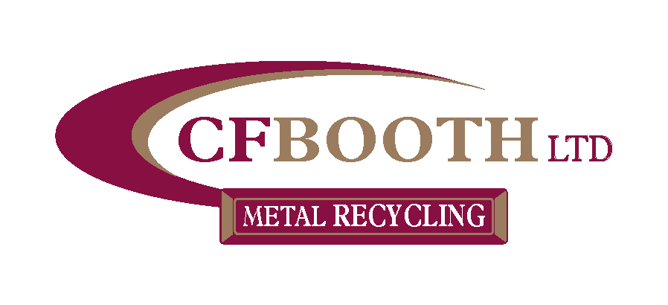

Corporate Social Responsibility Policy

Sound corporate activities
The CF Booth will ensure compliance with all applicable health, safety and environmental legislation, industry best practice and other stakeholder requirements and we will maintain a full awareness of future developments. We will exercise sound and fair corporate business practices, earn the trust of stakeholders such as customers, shareholders, employees, business partners, and society. CF Booth will maintain constructive relationships with all regulators, administrative bodies, remaining politically neutral and complying with laws, and will not engage in relationships with individuals or groups that threaten social order or safety.

Provision of valuable goods and services for society
The CF Booth aims to provide the complete waste management solution to all our stakeholders and will provide valuable products and services with superior quality and safety to society, endeavouring to increase the satisfaction and trust of our customers and contributing to the healthy development of society.

Respect for human beings
The CF Booth will respect diversity and individual human rights in which all persons receive fair treatment without discrimination. It will also oppose enforced labour and child labour and respect fundamental human rights as well as workers' rights. We are committed to preventing pollution, injury and ill health and ensure a safe and healthy environment for our employees, customers, visitors, contractors, general public and stakeholders at all our sites and wherever we operate in the community. We will identify, assess, and control all health, safety and environmental aspects and risks. We will maintain a safe working environment and ensure that our sites, plant and equipment are maintained in a safe condition

Protection of the natural environment
The CF Booth will proactively engage in environmental efforts and work to protect the natural environment, as these are common issues for all of mankind. We will promote the benefits of the waste hierarchy and support recycling and energy recovery initiatives. We will ensure optimum use of natural resources, raw materials and reduce carbon emissions where possible through efficient fuel and energy usage

Responsibility to society as a corporate citizen
The CF Booth will carry out corporate activities that take into account all cultures and practices and proactively engage in activities that contribute to society as a good corporate citizen. We will support local community and environmental improvement projects.

Socially responsible behaviour within the supply chain
The CF Booth will encourage socially responsible behaviour within its supply chain we will endeavour to recruit employees from the local community and source local suppliers and contractors to support the local economy.

Transparent operating activities
The CF Booth will communicate extensively with customers, shareholders, employees, business partners, and society and disclose business information in a timely and fair manner. We will also conduct reliable financial reporting through accurate accounting processes. We will engage, communicate and work closely with our neighbours close to our operations to try to ensure they are kept up to date with our plans and performance.

Responsibility of top management
Top management and employees in managerial positions within each department understand that they play an essential role in fulfilling the principles of this Policy and thus, in addition to leading by example, they must ensure that this information is disseminated to everyone in the company and all related parties. Management must always strive to understand the opinions of those both inside and outside of CF Booth to develop a sound internal framework that ensures that the spirit of this Policy is upheld.

This policy is hereby authorised by:

J. H. Booth - Director
16th January 2023

